Dis-Eur-England-Swanscombe Area, Kent-Acheulian Biface-350,000-200,000 BP

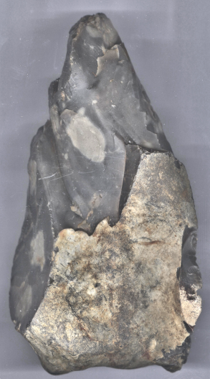 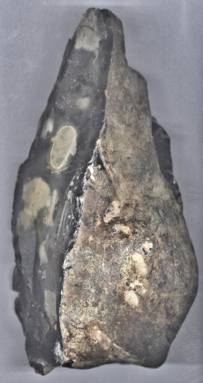

Fig. 1. Swanscombe Area, Kent-Acheulian Biface, 350,000-200,000 BP, ventral view

Fig. 2. Swanscombe Area, Kent-Acheulian Biface, 350,000-200,000 BP, dorsal view

**Formal Label:** England-near Swanscombe, Kent-Acheulian Biface-350,000-200,000 BP

**Accession Number: A13**

**LC Classification:** GN772.22.G7

**Date or Time Horizon:** 350,000-200,000 BP

**Geographical Area:** near Swanscombe, Kent, on the right bank of the Thames River.

**Map:** From Roe 1981: 95.

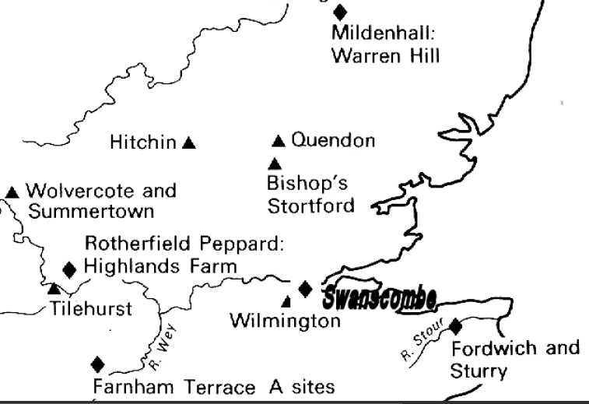

**Figure 3. Swanscombe, Kent (bold), and other Early Acheulian sites (diamonds);**

**also Late Acheulian sites (triangles).**

**Map:** from Keith 1916



**Cultural Affiliation:** Acheulian, Homo Heidelbergensis.

**Medium:** Flint.

**Dimensions: H 18 cm; W 11 cm.  
Weight:**

**Provenance: Old English Collection from 1920’s, found in an open pit quarry.**

**Condition:** This Acheulian biface is in museum grade condition showing expert working detail and ancient patination.

**Discussion:** This giant Acheulian biface, ca 350,0000 - 200,000 years BP found near Swanscombe, Kent, has been flaked from a thick elongated flint cobble and has been bifacially worked to form a robust distal point. The dorsal side retains a large cortical area at the proximal end; this cortical area continues along the right lateral edge and around the proximal end which is naturally rounded, being the surface of the flint cobble. The ventral side has been finished with retouches to the distal end.

**References:**

|  |
| --- |
| Conway, Bernard, John McNabb and Nick Ashton, eds. 1996. *Excavations at Barnfield Pit,* *Swanscombe, 1968-72*; illustrations by Phil Dean. London: Dept. of Prehistoric and Romano-British Antiquities.  Keith, Arthur. 1915. *The Antiquity of Man*. London.  Roe, Derek. 1981. *The lower and middle Paleolithic periods in Britain*. Series: Archaeology of Britain, Barry Cunliffe, ed. London, Boston and Henley: Routledge and Keegan Paul. |
|  |